GPU vs. CPU: Key Differences

1. CPU (Central Processing Unit)
- Purpose: The CPU is the general-purpose processor in a computer, optimized for sequential task execution and complex operations.
- Architecture: Few cores (typically 4–16 in consumer CPUs) with large caches and high clock speeds.
- Strengths:
  - Handles single-threaded tasks and general-purpose processing efficiently.
  - Best suited for tasks requiring complex decision-making and branching.
  - Optimized for low-latency operations.
- Examples: Running an operating system, word processing, and web browsing.

2. GPU (Graphics Processing Unit)
- Purpose: The GPU is a specialized processor designed for parallel processing, originally intended for rendering graphics.
- Architecture: Thousands of smaller, simpler cores capable of performing many tasks simultaneously.
- Strengths:
  - Excels at parallel processing and handling large volumes of simple, repetitive calculations.
  - Best suited for tasks like graphics rendering, machine learning, and scientific simulations.
  - Optimized for high-throughput operations.
- Examples: Rendering images, video processing, and accelerating AI model training.

Comparison Table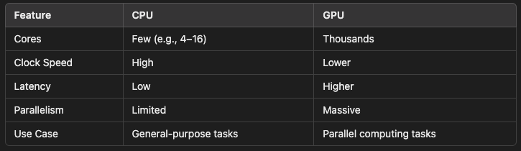

SIMD (Single Instruction Multiple Data)

What is SIMD?
SIMD is a parallel computing paradigm where a single instruction is executed on multiple data points simultaneously. It is commonly used to process arrays or perform vectorized computations.

How It Works:
- Single Instruction: A single operation is applied to multiple pieces of data.
- Multiple Data: Operates on vectors, meaning each core processes a chunk of data in parallel.

Examples in Practice:
- Graphics Rendering: SIMD is essential in GPUs, where the same transformation (e.g., rotation, scaling) is applied to thousands of pixels simultaneously.
- Machine Learning: SIMD speeds up matrix operations like multiplications, which are central to neural networks.
- Multimedia Processing: Video codecs use SIMD to apply the same filter to multiple pixels or audio samples in parallel.

Advantages of SIMD:
- Efficiency: Speeds up repetitive tasks by reducing the need for loop iteration.
- Parallelism: Greatly improves performance for data-parallel tasks.
- Power Savings: Reduces the number of instructions executed, saving power.

Comparison to CPU/GPU:
- SIMD is a computing method used by both CPUs and GPUs.
  - CPUs: Use SIMD instructions like Intel’s SSE or AVX for parallel processing.
  - GPUs: Rely heavily on SIMD due to their inherently parallel architecture.

Example of SIMD:
Imagine you want to add two arrays of numbers:

Without SIMD:
Each addition is performed sequentially:
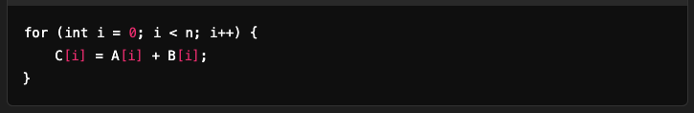

With SIMD:
Multiple additions are performed simultaneously:


Summary
- CPU vs. GPU:
  - CPU is versatile and optimized for sequential, low-latency tasks.
  - GPU is specialized for parallel, high-throughput tasks like rendering and AI.
- SIMD:
  - SIMD is a technique for parallelizing operations on multiple data points using a single instruction.
  - It is a cornerstone of modern GPUs and is also utilized in CPUs for performance-critical applications.
By leveraging GPUs and SIMD, modern computing achieves exceptional performance for data-parallel workloads like graphics and machine learning.

